ASSESSMENT TOOL 3: Application Based Questions

NAME: M. Vaishali
REG NO:192524440
COURSE NAME: Cloud Computing and Big Data Analytics
1.company experiences unpredictable traffic spikes during seasonal sales. Explain how cloud auto-scaling and load balancing can handle this demand efficiently. How does this approach reduce downtime and improve user experience? What role do monitoring tools play in this setup? Relate your answer to a real-world e-commerce scenario.
Cloud Auto-Scaling
- Automatically increases cloud servers when traffic increases.
- Removes extra servers when traffic decreases.
- Ensures enough resources are available during seasonal sales.
- Reduces cloud costs by using resources only when needed.
Load Balancing
- Distributes incoming user requests across multiple servers.
- Prevents any one server from becoming overloaded.
- Improves application performance and reliability.
- Ensures continuous service even if one server fails.

How It Reduces Downtime and Improves User Experience
- Prevents website crashes during heavy traffic.
- Provides faster page loading and quick response time.
- Enables smooth product browsing and checkout.
- Increases customer satisfaction and reduces revenue loss.

Real-World E-Commerce Scenario
- During the Amazon Great Indian Festival sale, millions of customers visit the website.
- Auto-scaling launches additional cloud servers to manage high traffic.
- Load balancing distributes customer requests evenly across all servers.
- Monitoring tools track system performance and trigger scaling whenever needed.
- Customers experience fast browsing, smooth checkout, and uninterrupted shopping.

2. An organization wants to store large volumes of backup data securely in the cloud. Discuss how cloud storage solutions ensure durability and data redundancy. How can encryption and access control protect sensitive backup data? Explain the cost advantages compared to traditional storage systems. Provide an example of a disaster recovery use case.
Cloud Storage Ensures Durability and Data Redundancy
- Cloud storage keeps multiple copies of backup data in different servers or data centers.
If one server or data center fails, data can be recovered from another copy.
- Ensures high durability and prevents data loss.
- Provides reliable long-term backup storage.
Encryption and Access Control for Security
- Encryption converts backup data into unreadable form during storage and transmission.
- Only authorized users with the correct decryption key can access the data.
- Access control uses user authentication and role-based permissions.
- Prevents unauthorized users from viewing or modifying sensitive backup data.
- Improves data privacy and security.
Cost Advantages Over Traditional Storage
- No need to purchase and maintain physical storage devices.
- Pay only for the storage used (pay-as-you-go model).
- Reduces hardware, maintenance, and electricity costs.
- Easily scales storage capacity without buying new equipment.
- Lower overall operational costs.
Disaster Recovery Use Case

A company stores daily backups of its customer database in the cloud.

A flood or fire damages the company's local data center.

The company restores its data from the cloud backup.

Business operations continue with minimal downtime and data loss.

3. A mobile app company plans to deploy its application globally. Explain how content delivery networks (CDNs) improve performance and reduce latency. How do edge servers enhance user experience across regions? Discuss how cloud providers support global availability. Relate this to a real-time streaming or gaming application.
Scenario
A mobile application company wants users from different countries to access its application quickly. If all application content is delivered from a single server located in one country, users who are geographically far away may experience increased latency.
A Content Delivery Network (CDN) helps solve this problem.
What Is a CDN?
A Content Delivery Network is a geographically distributed network of servers called edge servers or edge locations.
Instead of every user requesting content from the main origin server, frequently requested content can be served from a nearby edge location.
Example:
Origin Server → CDN Edge Locations → Users
How CDN Reduces Latency?
Suppose the main application server is located in the United States.
A user in India would have to send a request over a long network path to the US and wait for the response.
With a CDN:
Indian User → Nearby CDN Edge → Content
The content travels a shorter distance, reducing latency.
What Can Be Delivered Through a CDN?
CDNs are particularly effective for:
- Images
- Videos
- JavaScript files
- CSS
- Application assets
- Game updates
- Software downloads
- Streaming content
Role of Edge Servers
- Edge servers are located closer to users geographically
- Improvement in User Experience
- CDNs can provide:
- Lower latency
- Faster content delivery
- Faster application loading
- Reduced origin server workload
- Better streaming performance
- Improved scalability
- More consistent performance across regions
- This is particularly important for applications where users expect near-real-time responses.
- Cloud Support for Global Availability
- Major cloud providers offer global infrastructure consisting of:
- Multiple geographic regions

- Availability zones
- CDN/edge networks
- Global load balancing
- Distributed storage
- Managed databases
- Disaster recovery capabilities
- An application can therefore deploy services in multiple regions rather than relying on one physical datacenter.
- Real-Time Streaming Example
- Consider a global sports streaming application.
- During a major cricket match, millions of users may simultaneously watch live video. A single origin server could become overloaded.
- A CDN can distribute video content through edge locations:
- Streaming Origin → CDN → Edge Servers → Millions of Viewers
- A viewer in India receives content from a nearby edge location, while a viewer in Europe receives it from a European edge location.
- This reduces the distance that content must travel and helps the system serve a large global audience.

4.A financial institution requires strict compliance and data security in cloud usage. Explain how cloud providers support regulatory compliance and auditing. What role do logging, monitoring, and encryption play in security? How can the company ensure data sovereignty requirements are met? Give an example involving sensitive financial transactions.
Scenario
A financial institution handles highly sensitive information such as:
  - Bank account details
  - Credit/debit card information
  - Customer identities
  - Transaction records
  - Loan information
  - Payment information

Therefore, cloud deployment must provide strong security, auditing, compliance, and control over where data is stored.

Regulatory Compliance
Cloud providers offer services and controls that help organizations meet various regulatory and security requirements.
Depending on the organization's location and business activities, relevant requirements may include:
  - Financial-sector regulations
  - Data protection requirements
  - Privacy regulations
  - Industry security standards
Internal organizational policies
However, using a compliant cloud provider does not automatically make the customer compliant. The organization must configure its cloud environment correctly and follow the applicable regulations.

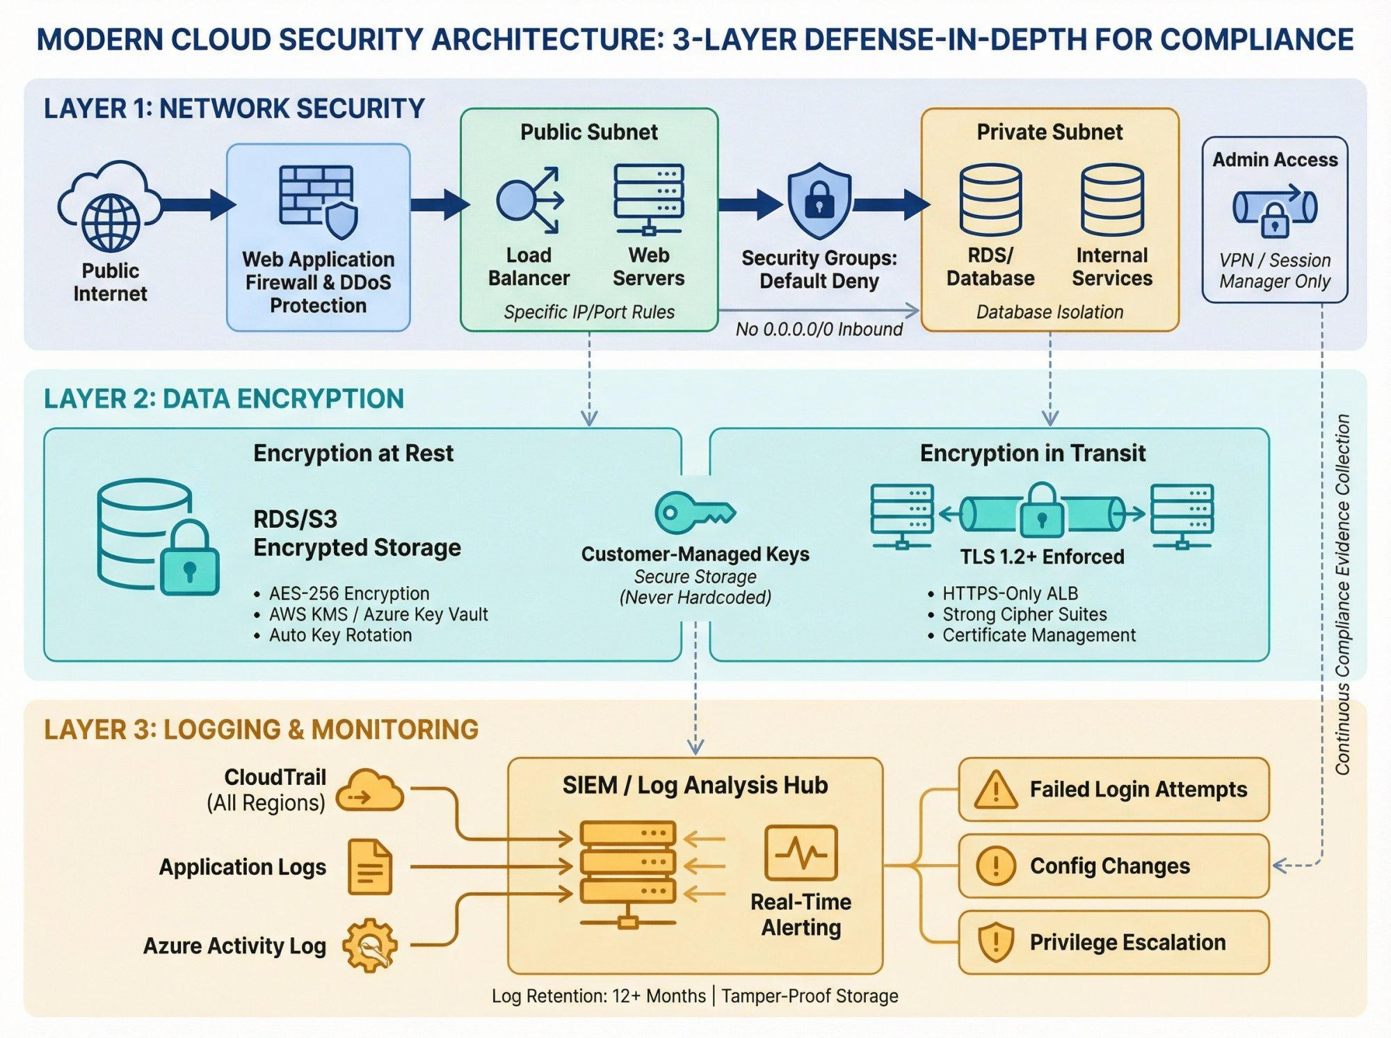

Auditing
Auditing provides evidence of:
  - Who accessed data
  - When the access occurred
  - What operation was performed
  - Which system was accessed
  - Whether configuration changes occurred

  - Whether suspicious activity occurred

For example:

Employee A → Accessed Transaction Database → 10:30 AM → Read Transaction Record
Such information can be reviewed during security investigations and compliance audits.
Role of Logging:
Cloud logging records important activities such as:
  - User logins
  - Failed login attempts
  - Database access
  - API calls
  - Configuration changes
  - File access
  - Administrative activities
Logs can help identify unauthorized activity.
For example:
Multiple Failed Logins → Security Monitoring Detects Abnormal Activity → Account Restricted → Security Team Investigates

Access Control
The financial organization should implement strong IAM controls.
Examples:
  - Role-based access control
  - Multi-factor authentication
  - Least-privilege permissions
  - Privileged access management
  - Separation of duties

For example:

Customer Service Employee: Can view permitted customer information.
Database Administrator: Can maintain database infrastructure.
Financial Auditor: Can access audit records but cannot modify transactions. This reduces the possibility of unauthorized modification.

Role of Monitoring:
Monitoring continuously observes the security and performance of cloud infrastructure. It can detect:
  - Unusual login behaviour
  - Unexpected network traffic
  - Excessive API requests
  - Abnormal database activity
  - Resource changes

Security events
Monitoring combined with alerts allows the organization to respond quickly.
Role of Encryption
Financial data should be protected using encryption.
Encryption at rest:
Protects stored databases, files, backups, and storage volumes.
Encryption in transit:
Protects information while moving between users, applications, databases, and cloud services.
For example:
Customer → Encrypted Connection → Banking Application → Encrypted Database
Encryption reduces the risk of sensitive information being exposed.

Data Sovereignty
Data sovereignty refers to requirements concerning the country or jurisdiction in which data is stored and processed.
If financial regulations require customer information to remain within a particular country, the organization can:
- Select an appropriate cloud region.
- Store sensitive databases in that region.
- Restrict replication to approved regions.
- Control cross-border data transfers.
- Monitor data movement.
Maintain appropriate audit records.

Data Sovereignty
Data sovereignty refers to requirements concerning the country or jurisdiction in which data is stored and processed.
If financial regulations require customer information to remain within a particular country, the organization can:
- Select an appropriate cloud region.
- Store sensitive databases in that region.
- Restrict replication to approved regions.
- Control cross-border data transfers.
- Monitor data movement.
Maintain appropriate audit records

- Sensitive Financial Transaction Example Consider an online banking application.
A customer transfers ₹50,000 to another account. The system should provide:
Customer Authentication → Transaction Request → Authorization → Encrypted Processing → Database Update → Audit Log

5. A development team wants to adopt containerization for application deployment. Explain how containers differ from virtual machines in terms of performance and resource usage. How does orchestration (like Kubernetes) simplify deployment and scaling? Discuss portability benefits across different cloud environments. Provide an example of a microservices-based application.

Scenario:
A development team wants to deploy an application efficiently across different cloud environments. Traditional application deployment can be difficult because the application may depend on a specific operating system, library, runtime, or configuration.
Containers solve many of these problems by packaging an application together with its required dependencies.

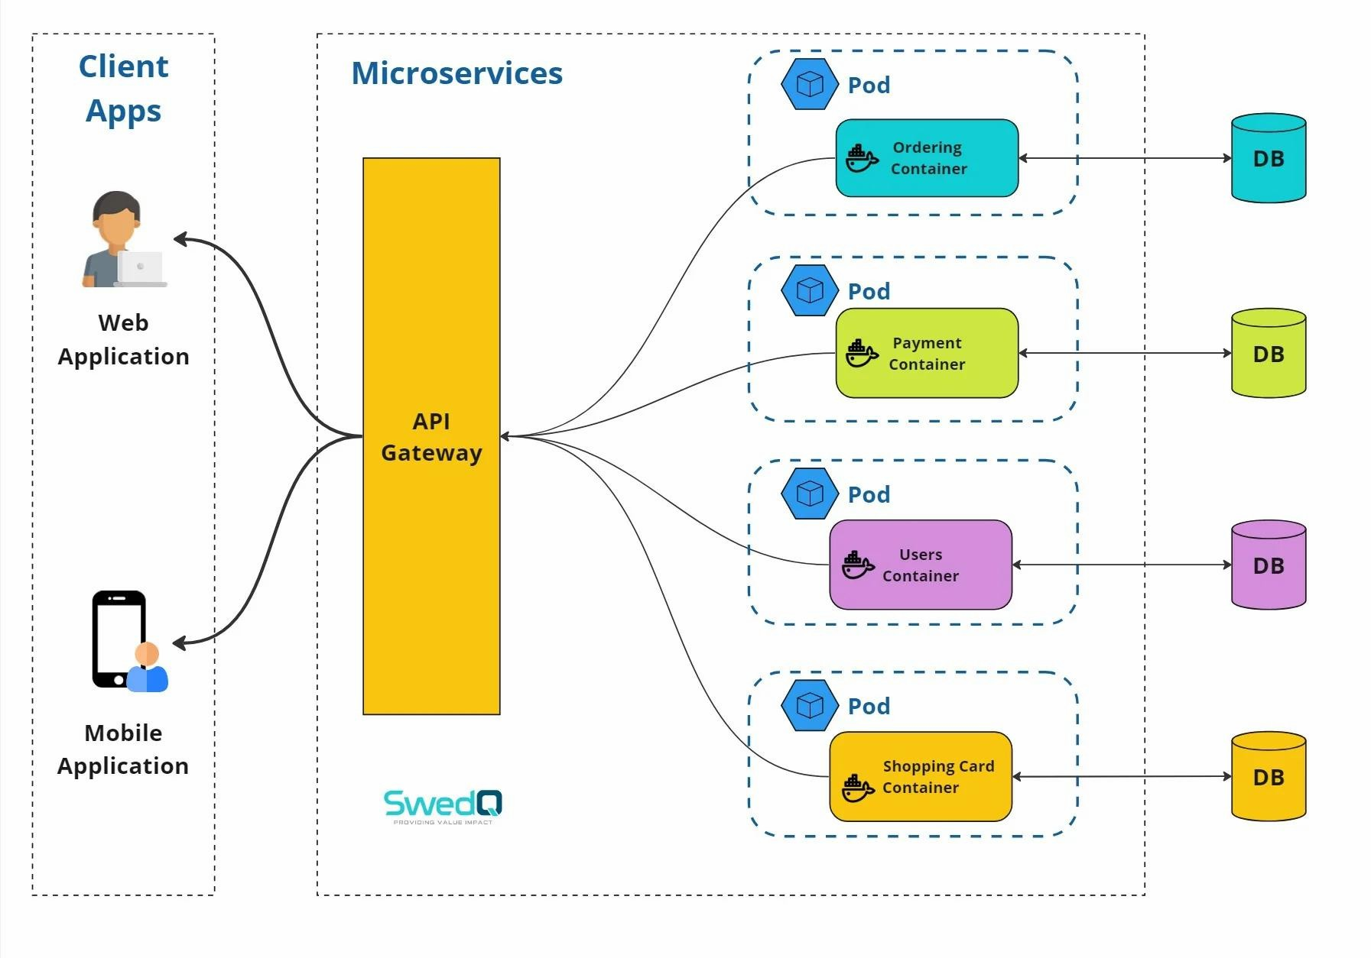
Containers vs Virtual Machines
Both containers and virtual machines provide isolation, but they work differently.

Virtual Machines:
A VM includes:
Physical Hardware → Hypervisor → Guest OS → Libraries → Application
- A VM runs a complete guest operating system on virtualized hardware.
- Each VM has its own OS, libraries, and applications.
- VMs generally require more CPU, memory, and storage.
- They take more time to start compared with containers.
- VMs provide strong isolation between workloads.
- Suitable for running different operating systems on the same physical server.
- Containers:
- Containers share the host operating system kernel while isolating applications. Architecture:
- Physical Hardware → Host OS → Container Runtime → Containers → Applications
- Containers package an application and its dependencies together.
- Containers share the host operating system kernel.
- They require less memory and storage than VMs.
- Containers start very quickly.
- More containers can run on the same hardware compared with VMs.
- They are highly suitable for microservices and cloud-native applications.
- Containers are easier to move between different cloud environments
- Performance and Resource Usage
- Containers are generally lightweight because they do not require a separate complete guest operating system for every application.

For example:
- VM approach:
- 10 applications → potentially 10 guest operating systems.
- Container approach:
- 10 applications → containers share the underlying operating system kernel.
- This can improve resource utilization and allow more application workloads to run on the same infrastructure.
- Role of Kubernetes
- When an organization has only a few containers, manually managing them may be possible. But a large application may have hundreds or thousands of containers.
- Kubernetes is a container orchestration platform that helps manage containerized workloads.

- It can automate:
- Deployment
- Scaling
- Load balancing
- Service discovery
- Container scheduling
- Health checks
- Rolling updates
- Self-healing
- Restarting failed containers
How Kubernetes Simplifies Deployment
- Suppose an application requires:
- 3 frontend containers + 5 payment containers + 4 database-service containers
- Instead of manually managing every container, Kubernetes can manage these workloads as services.
- If a container fails:
- Container Failure → Kubernetes Detects Failure → Replacement Container Started
- If traffic increases:
- High Traffic → Kubernetes Scaling → Additional Containers
- This improves application availability and reduces manual administration.
- Portability Across Cloud Environments
- Containers provide a consistent packaging format.
- For example, an application container can be deployed on:
- Private cloud
- Public cloud

- Hybrid cloud
- On-premises infrastructure
- Different Kubernetes environments
- The application can therefore move between cloud environments with fewer changes than an application tightly coupled to a particular server environment.
- Microservices Example
- Consider an online shopping application.
- Instead of building the entire application as one large application, it can be divided into microservices:
- E-Commerce Application
- → User Service
- → Product Service
- → Shopping Cart Service
- → Order Service
- → Payment Service
- → Notification Service
- → Inventory Service
- Each service can run in its own container.
- For example:
- User Service → Container 1
- Product Service → Container 2
- Cart Service → Container 3
- Payment Service → Container 4
- Order Service → Container 5
- Kubernetes can manage these containers and scale individual services independently.
- For example, during a major sale:
- Product Service Traffic ↑ → Scale Product Service
- while the less-used services may remain at their normal capacity.

Advantages of This Approach
Containerization provides:
- Lightweight deployment
- Faster startup
- Better resource utilization
- Application isolation
- Consistent environments
- Easier testing
- Easier deployment
- Portability
- Independent microservice scaling
Kubernetes further provides automated orchestration, scaling, service discovery, and recovery

